A Sample Mathematics Document

Dee Y. Deetee

Carthage College

[dydt@carthage.edu](mailto:dydt@carthage.edu)

October 14, 2019

**Abstract**

Your abstract should contain a brief summary of your results. Aim for around 250 words. This will probably be the last thing you write.

**1 Introduction**

The introduction introduces your reader to your project. Technical language and notation are generally not appropriate in this section.

**2 Definitions and Development**

Here is where you get technical. Derive your equations, develop you model, state basic definitions formally, etc. You will almost certainly need some definitions similar to Definition 1, so use this format.

**Definition 1** A **new term** is an expression that you have not used before and that your reader needs to know about.

Of course, once you have a new definition, you will probably have a theorem or two telling us about what you discovered about your new term.

**Lemma 2 (Little Theorem)**  If $x$ is a new term, then $x$ is important to your readers. Small results might go here, but most theorems belong in the Results Section.

*Proof.* If the term was not important, you would not need to define it. ▀

**Example 3** Examples should be numbered too.

Of course, we can refer to a theorem as Lemma 2 or as Fake Theorem. If you need to refer to Example 3, do so by number.

**3 Results**

What have you learned from what you did in the previous section? This section could contain graphs, tables, computations, proofs, etc. When you include equations or functions, you can put them into a sentence $f\left(x\right)=x^{2}\sin{x}$, or you can set them apart

$f\left(x\right)=x^{2}\sin{x}$.

Notice that you do need to punctuate. If you refer back to the equation, label it,

$x^{2}\sin{x=0}$, (1)

and avoid statements like “the equation below.” Instead, refer to Equation (1).

**Theorem 4 (Your Theorem)**  If $x$ is a new term, then $x$ is important to your readers. Your major results are here.

*Proof.* If the term was not important, you would not need to define it. ▀

The same holds for tables and graphs. Label the graph, include a caption, and refer to it via the label. See Figure 1.

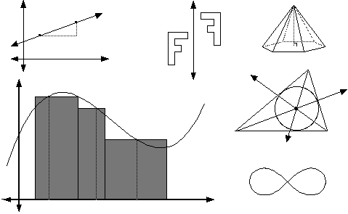

Figure 1: A Random Math Picture

**4 Conclusion and Directions for Further Research**

Draw some broad conclusions, and tell us what comes next.

**References**

[1] Lamport, L., *LATEX- A Document Preparation System*, Addison-Wesley, Chicago, 1998.

[2] Snavely, M., A Journal Example, *Fake Mathematics Journal*, **27** (2010) 12-15.

**Appendices**

If necessary, include appendices here.